[About](http://www.dailyclimate.org/about) | [Contact](http://www.dailyclimate.org/email_editor.html)



Top of Form

Top of Form



Bottom of Form

Kerry: 'We have lost the notion of responsible capitalism'

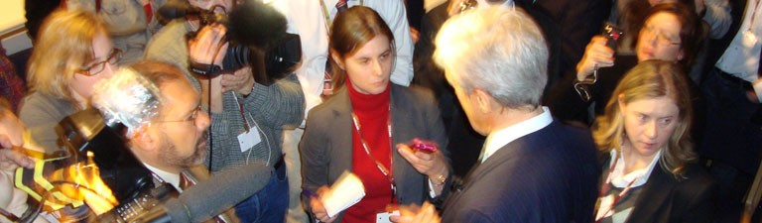

Sen. John Kerry addresses a scrum of reporters during the United Nations climate talks in Copenhagen in 2009. Since those talks, Kerry has seen little but frustration and defeat in efforts to craft a federal policy on climate change. Photo © DailyClimate.org.

**March 26, 2012**

**Venting frustration at the lack of progress on environmental issues, U.S. Sen. John Kerry voices the exasperation of a core constituency in President Obama's re-election bid.**

**By Doug Struck**

For the Daily Climate

BOSTON – Massachusetts Democrat Sen. John Kerry, exasperated at what he called "the flat-earth caucus," on Sunday described the frustrations of working on environmental issues in the U.S. Senate.

**People just turn off. It's extraordinary. Only for national security and jobs will they open their minds.**

* **Sen. John Kerry**

Even amid the "Tuesday Group" – a bi-partisan bloc of lawmakers, mostly Democrats, who are interested in energy issues – "you can't talk about climate now," Kerry said. "People just turn off. It's extraordinary. Only for national security and jobs will they open their minds."

Kerry, in a dinner speech at Tufts University Fletcher School of Law and Diplomacy, voiced the exasperation of an environmental movement that had high hopes with the election of President Obama in 2008 but has been disappointed by the administration and largely shut out after the Republican takeover of the House in 2010.

"The irony is that we used to be a nation that valued science. We have become a nation that is now discarding science," Kerry said. He spoke at a conference on the challenges facing the Arctic, attended by Iceland's president, Olafur Grimsson.

Kerry and Connecticut Sen. Joseph Lieberman, an independent, toiled through eight months of negotiation to draft a 2010 bill that would have capped carbon emissions and allowed trading of carbon credits, only to see it stymied in the Senate.

Opponents to the legislation "made up their own science. They made up their own arguments," Kerry said. "The Republicans created this idea of (carbon credit) trading because it avoided command and control by the federal government." Then, "they just decided to pick up and brand this a negative."

Kerry blamed brothers David and Charles Koch, oil billionaires who have bankrolled attempts to discredit climate change, as well as opposition from energy companies. "You have Peabody Coal. You have MidAmerican. They have these big old cash cows, these old coal-powered plants. It's just cash coming in, and they want to keep it that way.

"This is unrestrained, least-ethical, bottom-line capitalism," said Kerry, who ran unsuccessfully against George W. Bush for president in 2004 and now chairs the Senate Foreign Relations Committee. "We have lost the notion of responsible capitalism."

State and local governments have attempted to push ahead on efforts to minimize climate change. Without federal leadership, he said, the effort will struggle.

Failure to adopt a federal strategy is "unconscionable and tragic for the nation," he said. "Only by adopting a national policy can you create the kinds of jobs that are waiting or us."

"We are going to have to find a way to price carbon. Price carbon, and the market place will move forward very rapidly."

Photo of Sen. Kerry at a green jobs forum courtesy [**Ralph Alswang/Center for American Progress Action Fund**](http://www.flickr.com/photos/americanprogressaction/3488968132/).

 © Doug Struck 2012. All rights reserved.

Doug Struck covered climate change issues for The Washington Post and is a freelance writer and associate chair of journalism at Emerson College in Boston. DailyClimate.org is a nonprofit news service that covers climate change.